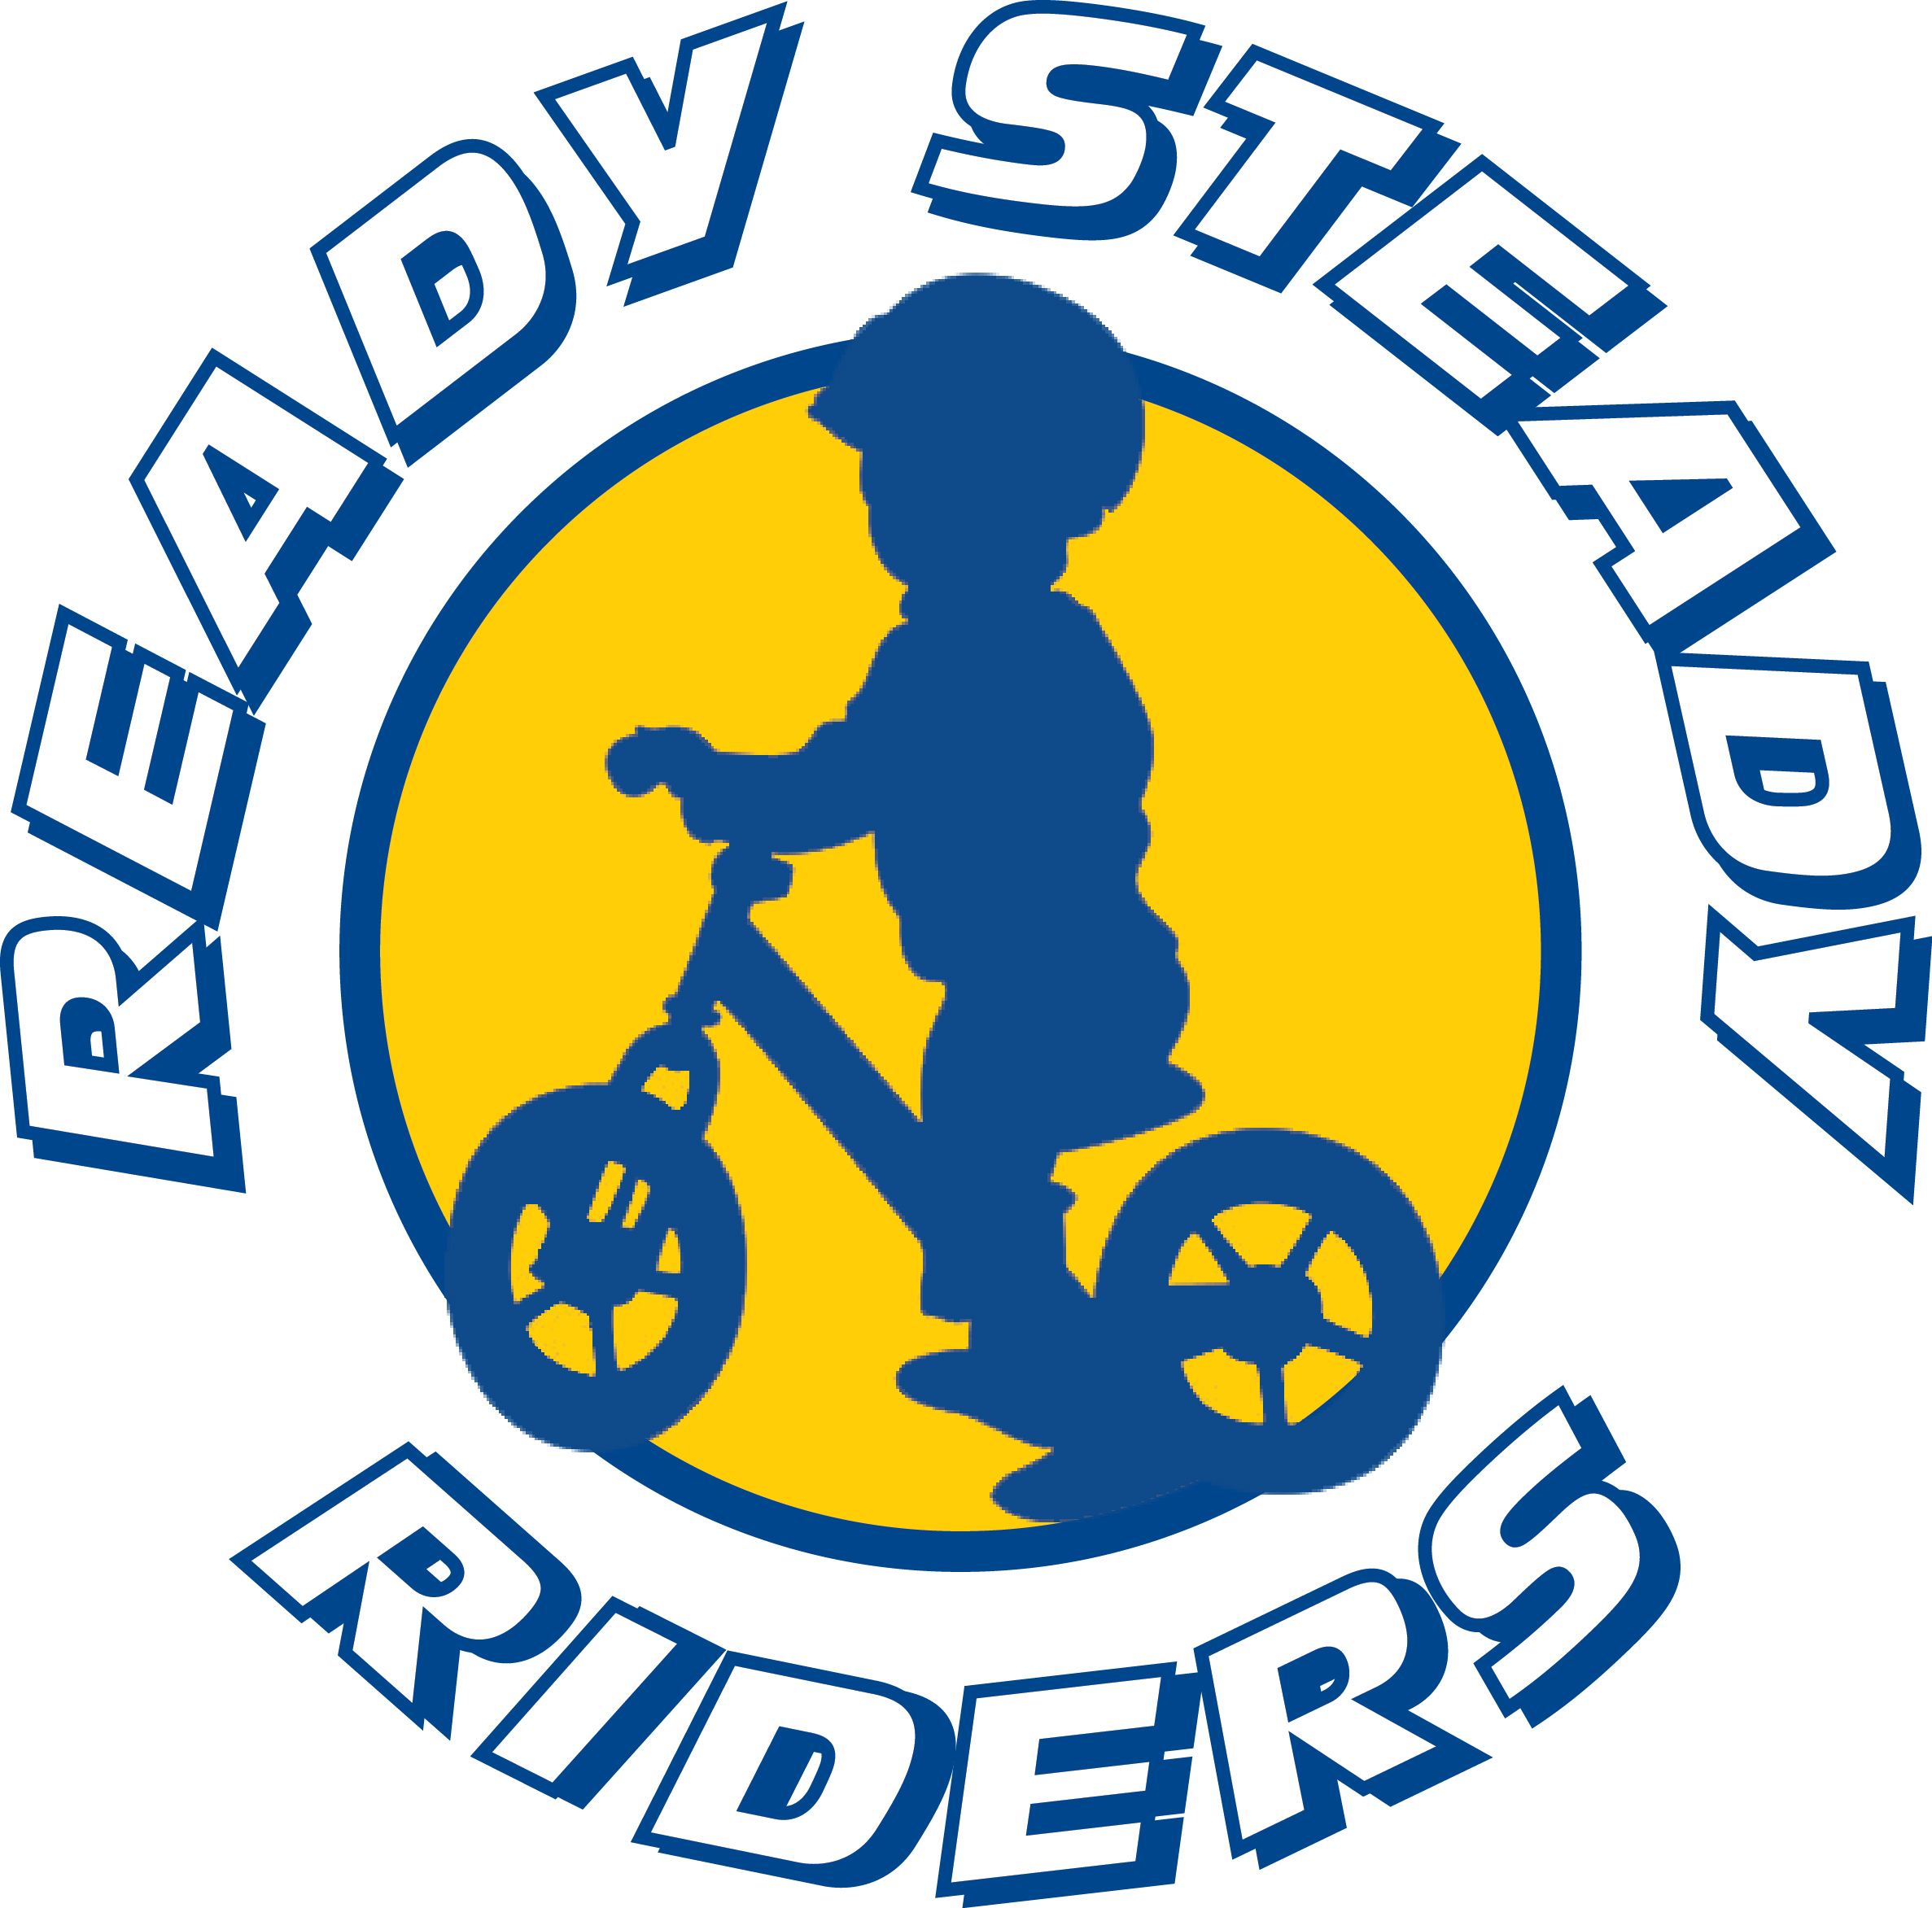
Rider Registration

Rider Details
Name
DOB
Details of any known allergies or conditions –

parent/guardian must carry any prescribed emergency medicines.

Parent Details
Name
e.mail
Phone
Address

Photography
I understand that at this event or related activities, I may be photographed. I agree to allow my photo, video or likeness to be used for any legitimate purpose by the event holders, producers, sponsors, organizers and or assigns.
In compliance with our child protection policy we require you please to indicate the following, (tick to agree)…
- I consent to images and/or footage of the above named child to be shared in the public domain.
- I consent to my child’s name appearing in the public domain.
- Please use the following alias name when referring to the above named child in the public domain - ………………………………
Release and waiver
I, the undersigned, hereby certify that I am the parent or guardian (Parent) of the child (Participant) indicated on this form, and, in exchange for the right of the Participant to participate in events and activities of Ready Steady Riders, relating to or occurring during the Ready Steady Riders session, and for me to enter into the participants’ area, give the following release and waiver. I hereby bind myself and the participant to the terms and conditions of this release and waiver. In addition to SC, this release and waiver applies equally to the Event Location and Employees Parent expressly agrees that Releasees shall not be liable for any damages arising from personal injuries sustained by Parent or Participant on or about the premises of Releasees or any area under control of Releasees or as a result of Parent or Participant using the facilities and equipment therein. Parent accepts full responsibility for any such injuries or damages which may occur to Parent or Participant on or about the premises or area under control of Releasees. Parent assumes full responsibility for any injuries, damages or losses which may occur to Parent or Participant and forever releases and discharges Releasees and their owners, employees, and agents from any and all claims and/or damages.

Parent Signature ___________________________________________________ Date

