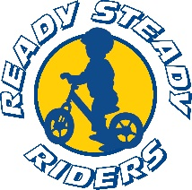
Rules

  - No Helmet No ride.
  - Gloves, elbow and knee pads recommended.
  - No open toe shoes.
  - When you fall, ALWAYS get back on.
  - No exposed handle bar ends.
  - Do not ride the BIG track without coach Kazzi unless instructed to do so.
  - Children must be supervised by a parent or guardian at all times.
  - All riders must registered by a parent or guardian before riding.
  - Foul language = 0 tolerance.
  - Be kind and have fun!

